**2022 First JQCM**

At 3:00 PM on February 28th, SUES and FHGR held 2022 first Sino-Swiss Joint Quality Management Team (JQCM) video conference. Shen Qin, Dean of Higher Vocational and Technical College; Li Yuanyuan, Deputy Director of Academic Affairs office; Xiao Qian, Deputy Director of International Cooperation and Exchange Office; Yuan Jianchang, Teaching director of Sino-Swiss Cooperative Education Program; Patric Arn, Head of Institute for Tourism and Leisure FHGR; Bianka Lichtenberger, Head of Quality Management; Thuc Lan Tran, Director of Joint Program, attended the meeting.

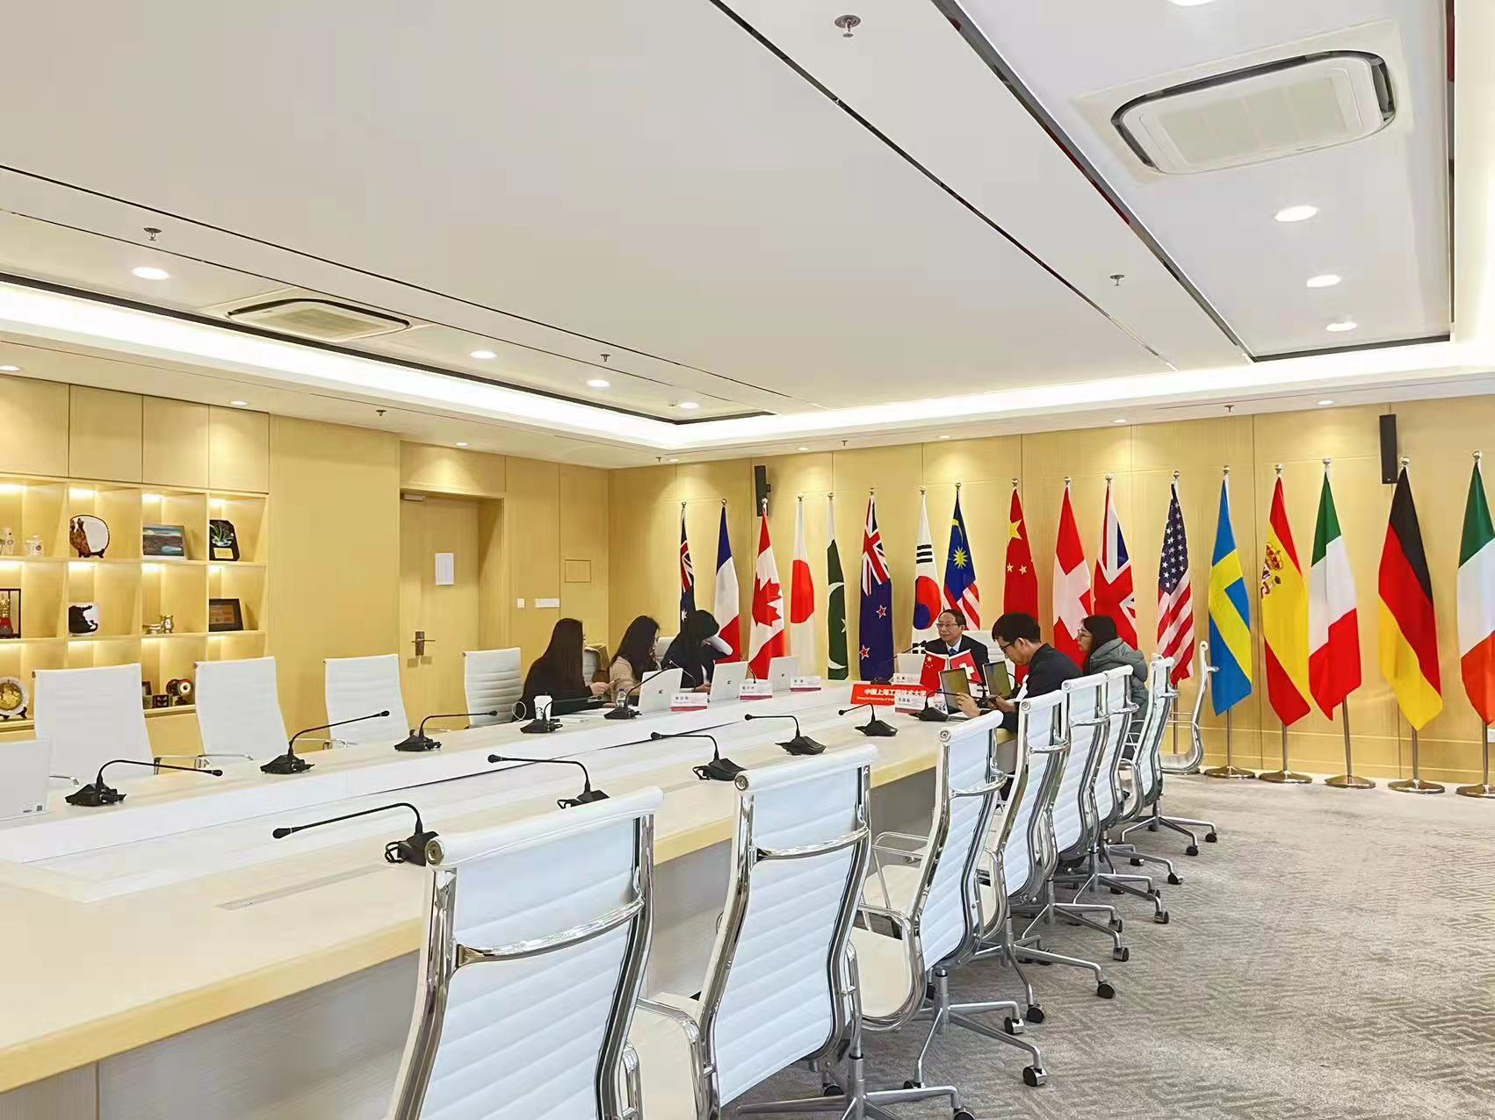

According to the new cooperation agreement between SUES and FHGR, a joint quality management system is set to ensure the quality of cooperative education projects and guarantee high quality teaching level.

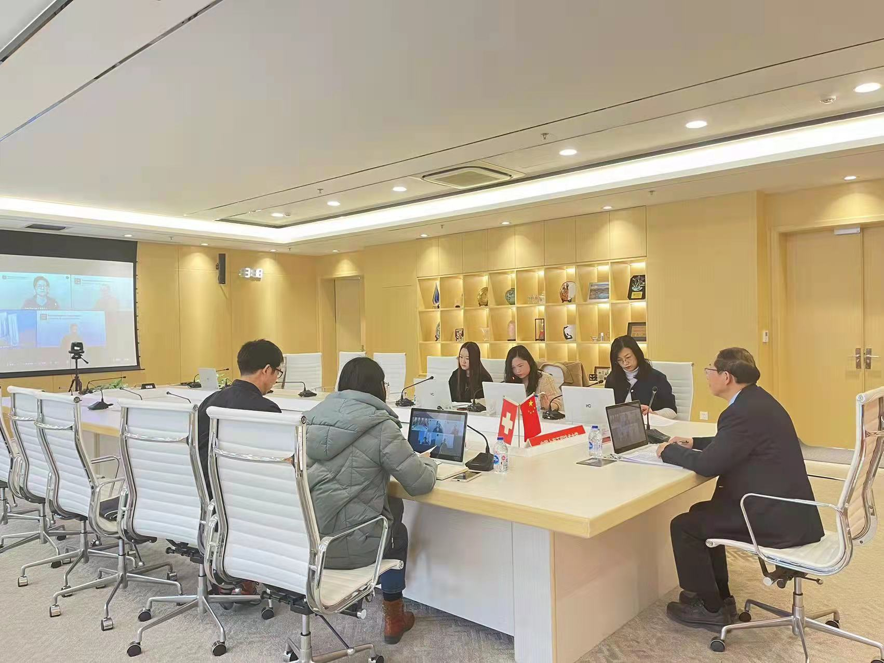

The meeting was presided by Prof. Shen, Prof. Yuan reported the evaluation results of five modules (Consumer Behavior, Intercultural Competences, Introduction to Tourism, Service Management, Tourism Law) in autumn semester 2021. The two sides introduced and discussed the results of evaluation of five modules in autumn and asked questions and answered about the teaching situation of FHGR. In addition, they also introduced the key work of teaching quality in 2022. Later, Deputy Director Li Yuanyuan introduced the professional certification work of SUES, and explained one by one.

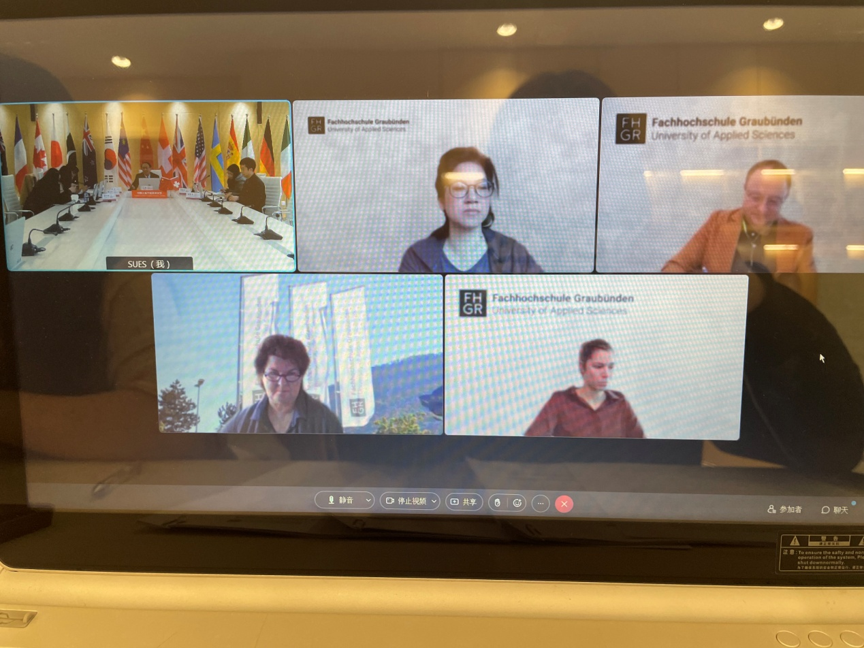

The meeting was held in a warm atmosphere. SUES and FHGR reached a consensus on jointly designing the teaching evaluation questionnaire, and fully exchanged opinions and ideas on the curriculum content design, so as to strictly control the quality of cooperative education and ensure the learning effect of students in our program.

管沉吟（文）